**Movable** **Counterweight** for Excavators

A counterweight is an equivalent counterbalancing weight that balances a load. Its purpose is to make lifting the load more efficient, which saves energy and is less taxing on the lifting machine

In Excavators equilibrium or the balance is the major part when it works. Because if we lift more loads we need to have more stability simply saying that needs more counterbalance.

But the significant fact is, more weight means more power consuming. In present Excavator machines, we seeing heavy counterweight permanently fixed at the backside of the machine.

Problems found

* Unnecessary Energy and fuel wastage, when machine travelling due to the Heavy counterweight.
* Wearing of sprocket, rollers and other undercarriage parts due to unnecessary weight at the back of the machine.
* Travelling speed decreases

Solution.

Auto or manually adjustable counterweight with light weight, when compare with the same weight class machines.

Advantages due to solution

* Fuel efficiency increased up to 9.8% when travelling
* Low of Ground pressure
* 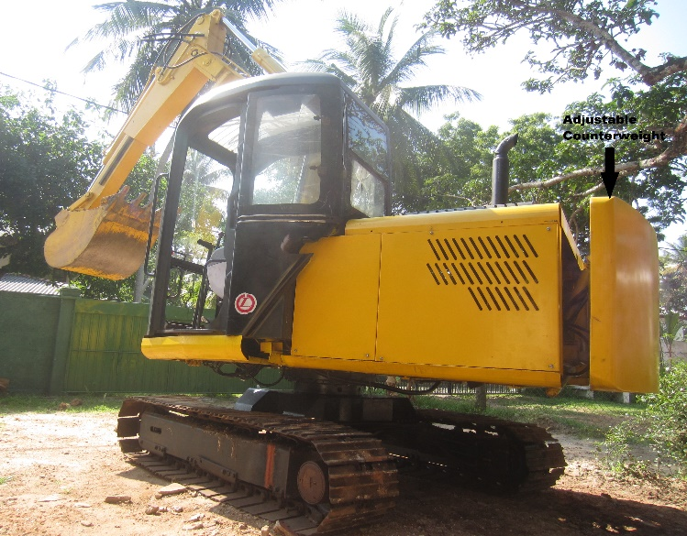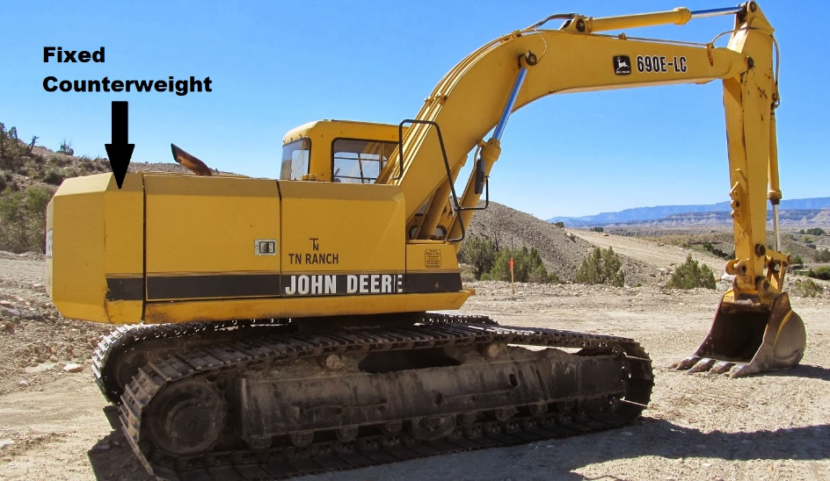High travelling speed